Encoder Interface T4

https://github.com/janelia-experimental-technology/Treadmill-Interface

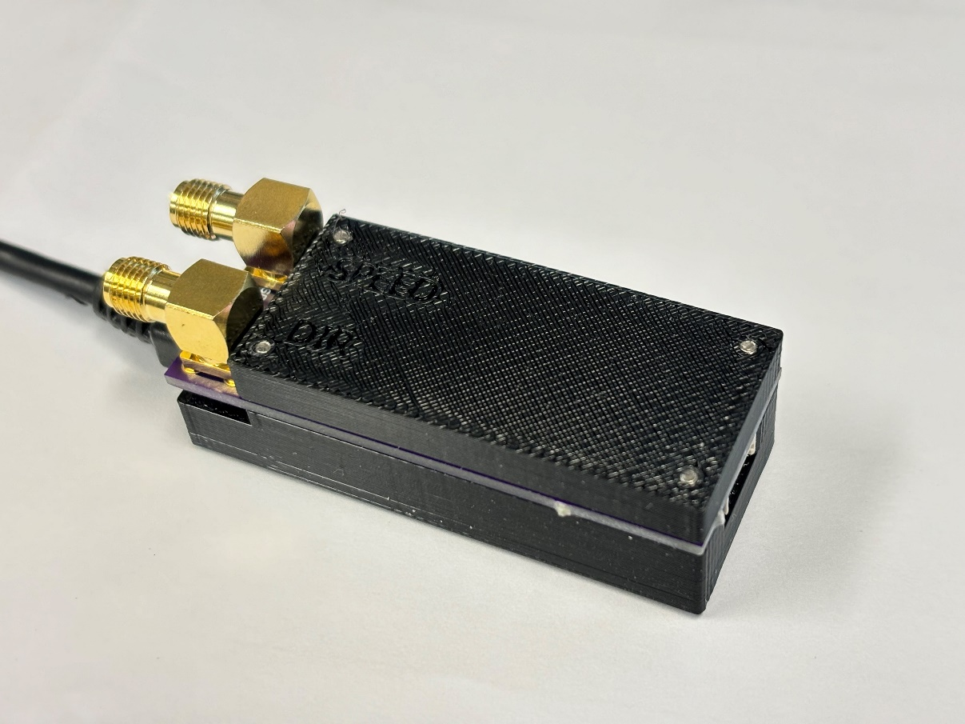

Steve Sawtelle  
Engineer, jET

Contents

System Overview 2

Hardware Development 2

Firmware and Calibration 3

# System Overview

The Encoder Interface provides a method to connect a quadrature encoder to serial and analog interfaces. The emphasis is on simplicity and ease of assembly. The interface reads the encoder and calculates distance, speed, and direction based on time between encoder edge changes using the internal timer on the processor. These values are updated every time it changes until the updates exceed a selectable maximum update rate. If no changes are detected over a set time (typically 50 milliseconds) the speed is set to 0. The USB-serial connection prints the distance and speed every change. The analog output sets a voltage proportional to absolute speed (as it is a unipolar output), and a digital output provides direction information. The calibration of speed, distance, and output voltage can all be customized.

# Hardware Development

The design is based around a Teensy 4.0 processor. The encoders used in Janelia treadmills require a 5-volt supply, so a level translator is required to interface with the 3.3-volt inputs of the Teensy. The Teensy does not have a standard digital-to-analog converter, so a pulse-width-modulated output is used, along with a low pass filter and buffer amplifier.

The encoder connection is set up to connect to the treadmill encoder using an off-the-shelf cable:

Molex 151315134050X

Note that this cable reverses pinouts at the two ends, so maintain this wiring if building a custom cable.

# 

# Firmware and Calibration

The firmware was developed under the Arduino environment.

Various values may need to be modified to suit a particular treadmill setup. The calibration can be checked by moving the treadmill belt a set distance and calculating the difference in the start and end points sent over the serial port. The analog output speed range also be adjusted. The default values are set to work with the Rodent-Belt-Treadmill:

<https://github.com/janelia-experimental-technology/Rodent-Belt-Treadmill>

These are the values that can be modified:

SHOW_MICROS – if defined, then the running micros value will be output to the serial port along when new data is sent.

SHOW_REVERSE – if defined, then reverse running will subtract distance (and calculate negative speed).

SPEED_TIMEOUT – Zero speed will be assumed if no encoder interrupts occur within this many microseconds.

SHOW_ZERO – if defined, will output 0 speed after SPEED_TIMEOUT microseconds.

CYCLINDER_8IN – for the 8-inch cylindrical treadmill, extra interrupts are set to get additional resolution in the speed and distance since the treadmill moves further for each encoder count.

UPDATE_USECS – this defines the maximum update rate in microseconds. Without this, at fast treadmill speeds, there may be too many updates for the host computer to keep up with. When this occurs, the average speed is used.

MAXSPEED - the speed (mm/sec) that will cause the maximum voltage output (assuming 0 mm/sec is 0 volts).